IBM Watson Studio

Contents

Machine Learning 1

IBM Cognos Dashboard Embedded 3

# Machine Learning

Create an instance of IBM Watson Machine Learning

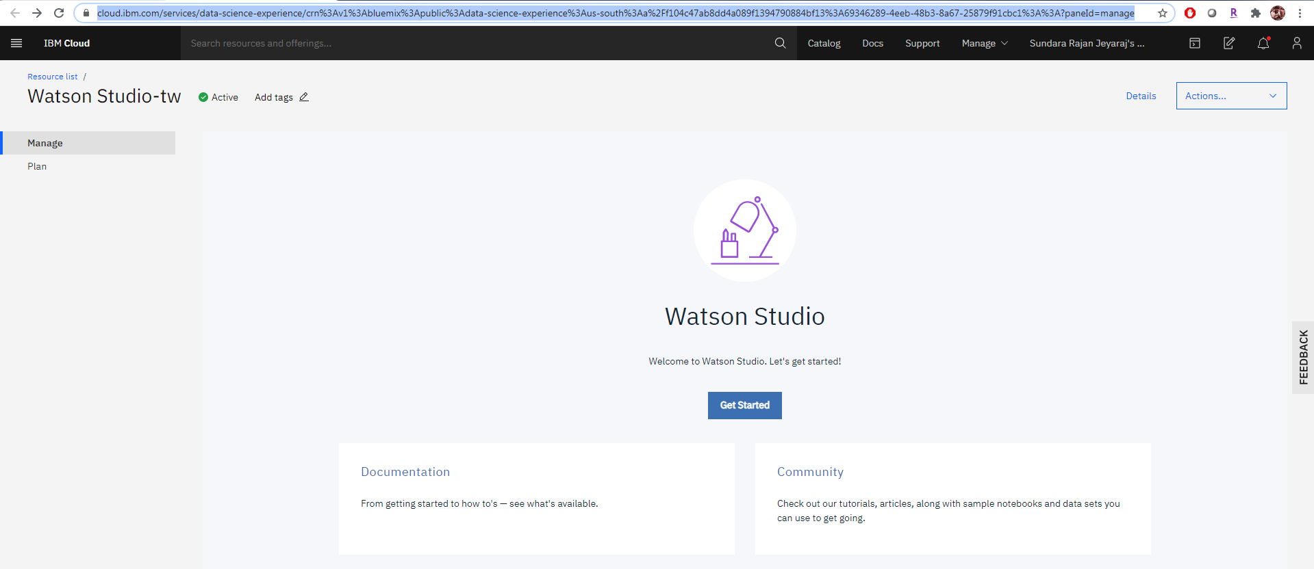

Auto AI

Refer documentation available in below link on how to create Auto AI ML model in Watson Studio

<https://dataplatform.cloud.ibm.com/docs/content/wsj/analyze-data/autoai-overview.html?audience=wdp&context=cpdaas>

Soil Moisture Dataset

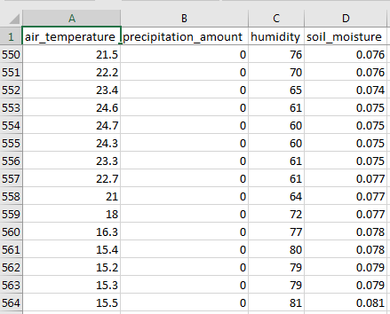 

Need to complete till deploying the Auto AI ML model as a Web Service in Watson Studio

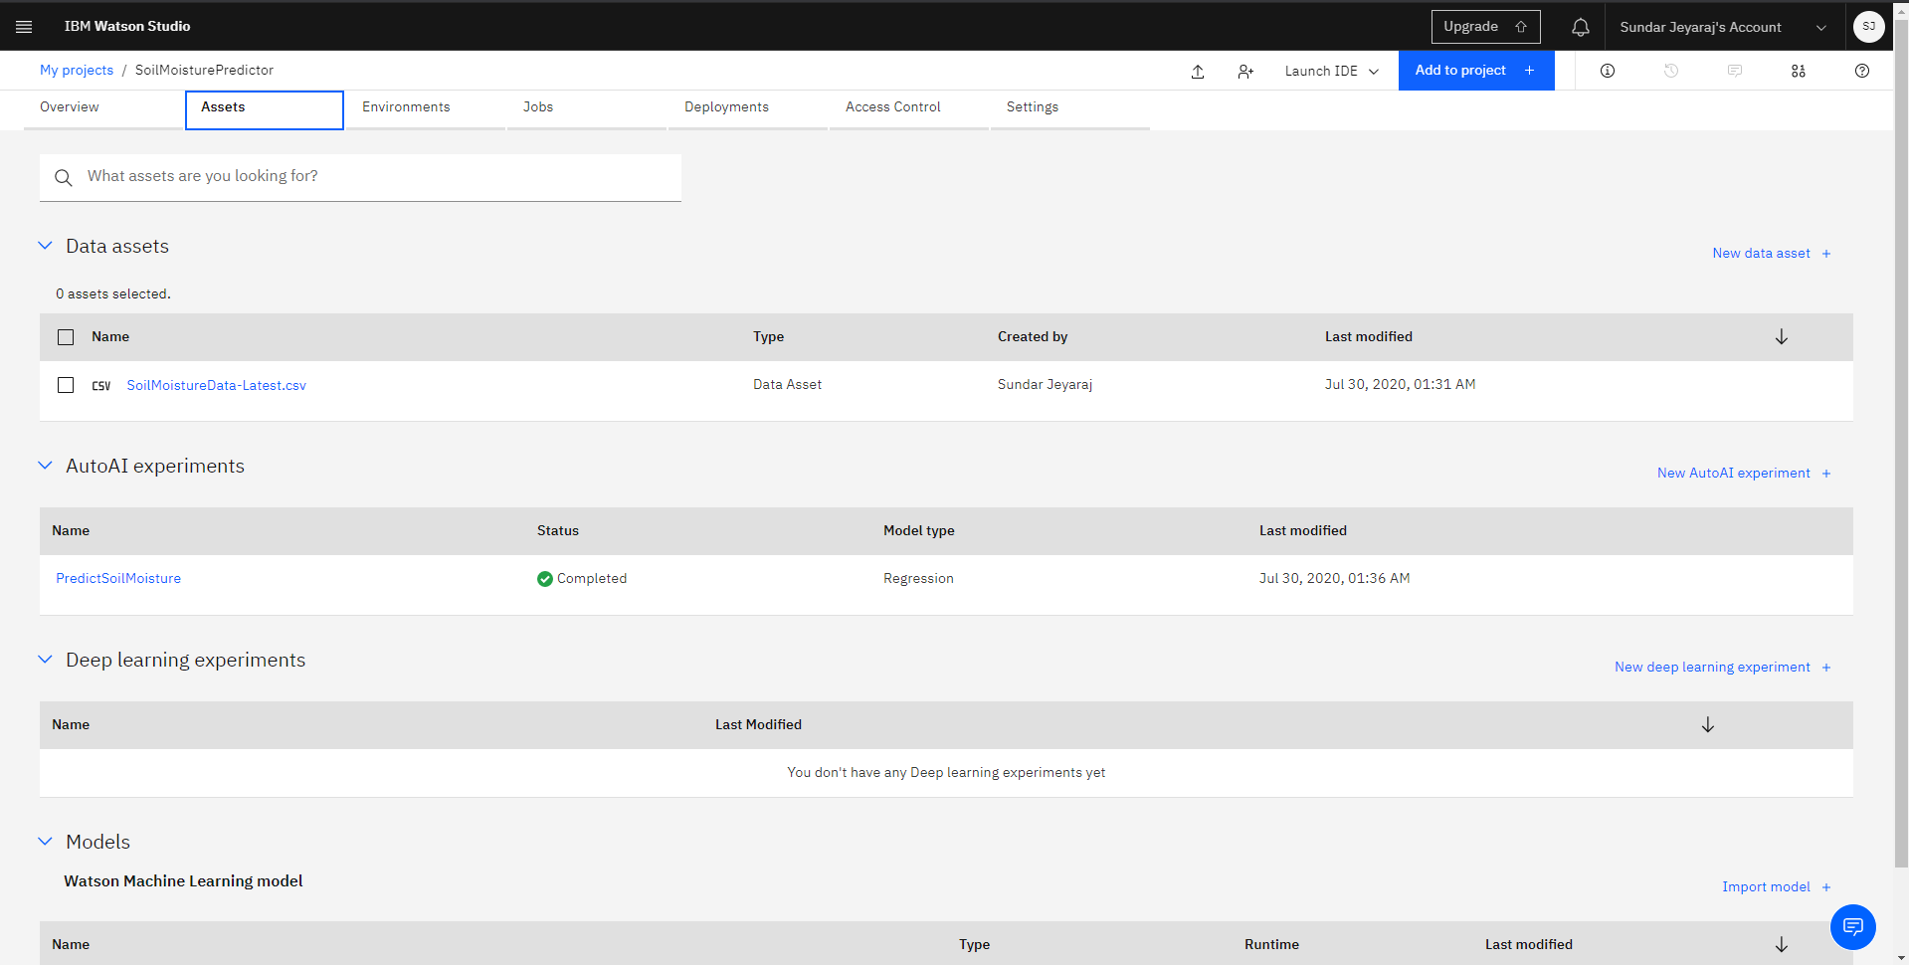



Watson Studio Dashboard

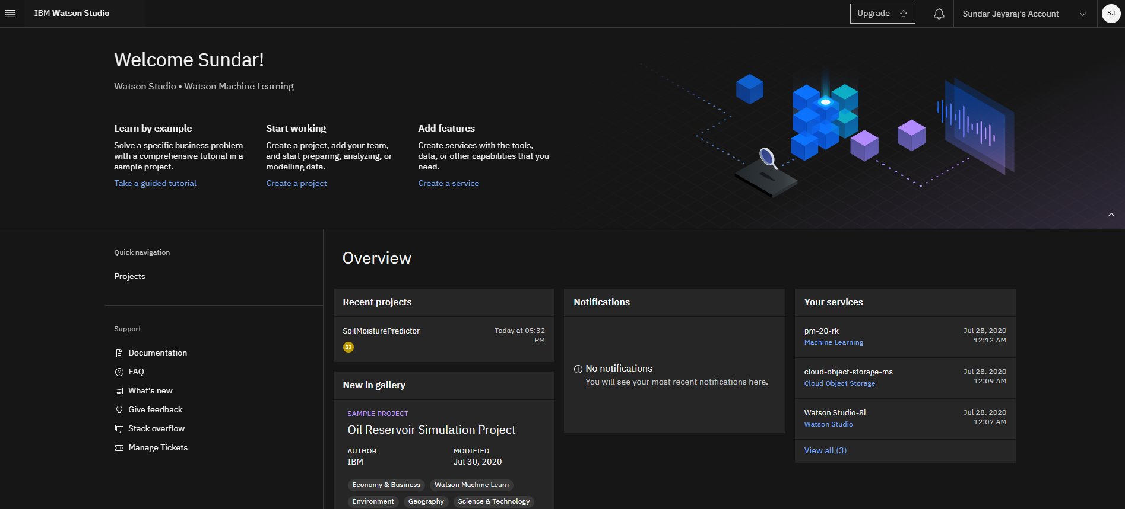

# IBM Cognos Dashboard Embedded

Create an instance of IBM Cognos Dashboard Embedded in the project created in Watson Studio

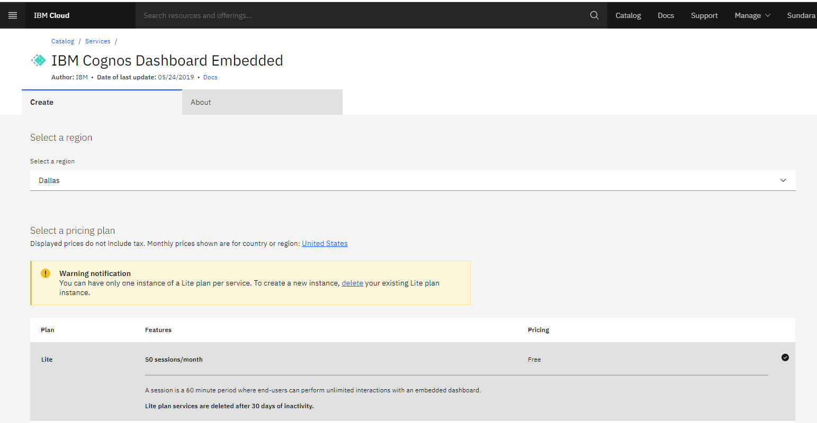

Reference doc: <https://cloud.ibm.com/docs/cognos-dashboard-embedded/index.html>

Forecast Insight is the new Dashboard created for Soil Moisture Predictor project in Watson Studio using IBM Cognos Dashboard Embedded service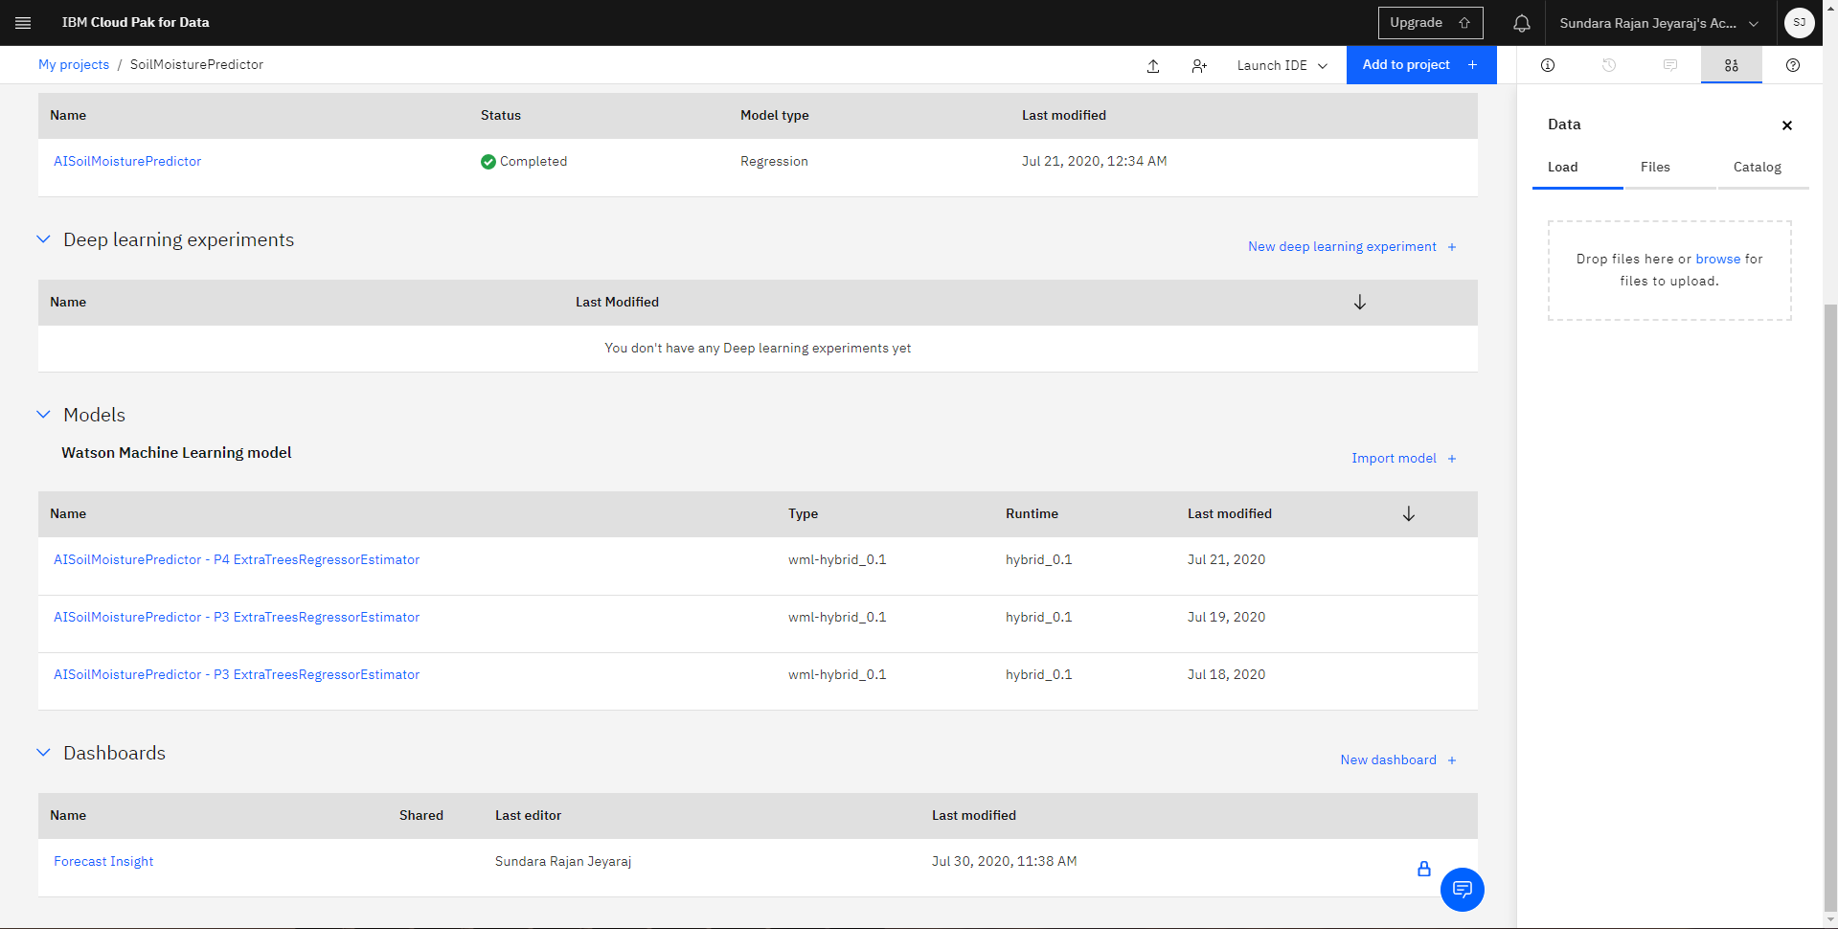

Select the source as DB2 connection 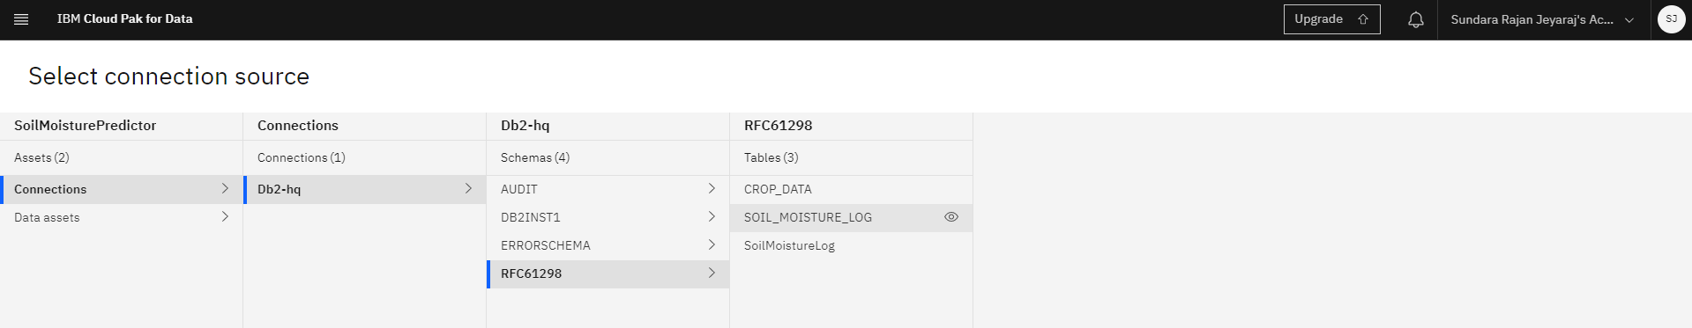

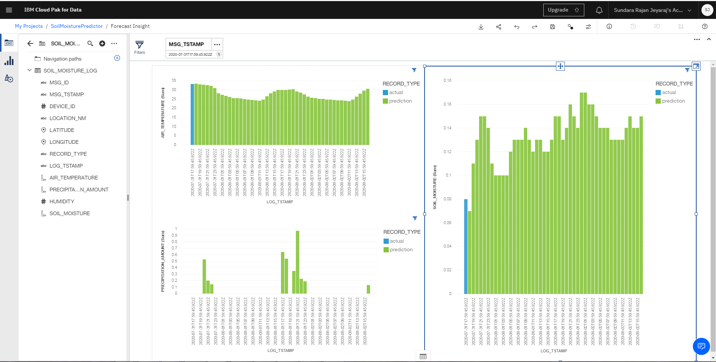

Share this dashboard with anyone having the link to make it publicly available

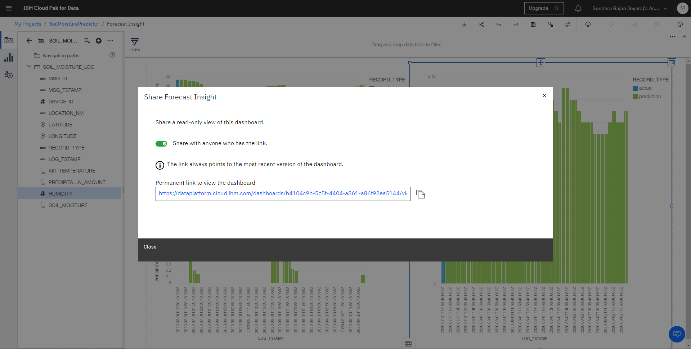

Dash board URL

<https://dataplatform.cloud.ibm.com/dashboards/b4104c9b-5c5f-4404-a861-a86f92ea5144/view/061ce51d238f6fc473ced4e4079a24022b352c5ab3bb8a05d68c7b4908637597a93c47c3c87c1d5dd2105635a5e8165c9b>